What the tsunami did to Phi Phi
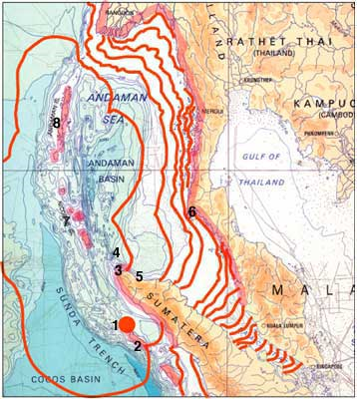
More than two hours after the Simeulue Island earthquake, the wave hit the west coast of Phuket. 45 minutes later it passed Phi Phi island from the west.

The first part of the wave was a trough. This caused the water to recede rapidly from both bays, leaving fish and boats stranded on the sea floor, and the coral exposed. Tourists and local people were curious, and followed the water out. Some people collected fish.

After a few minutes, at 10.37 am, the water came back at approximately 50 kilometres per hour (30 mph), much higher than the normal sea level.

The wave that came into Ton Sai Bay was 3 metres (10 feet) high. The wave that came into Loh Dalum Bay was 6.5 metres (18 feet) high. Waves also passed over the island from Laa Naa Bay to Bakhao Bay, and at Sea Gypsy Village (Laem Thong).

The waves crashed into the shoreline, doing huge damage to the seafront buildings. They then surged forwards, smashing everything in their path, and met each other in the middle of Ton Sai village. The larger wave pushed the smaller wave back, and a vast amount of water and debris surged across the isthmus into Ton Sai Bay. On the east of the isthmus, the larger wave drove up towards the hill.

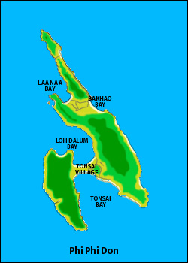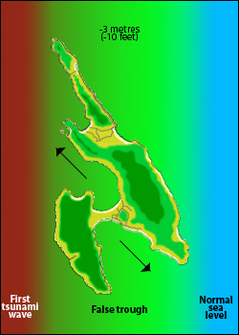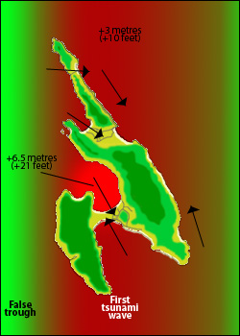

The eastern side of the island experienced some flooding but much less destruction.

After a few minutes a second trough passed the island and the water ran out for a second time. Then the water returned again. Finally the sea returned to normal.

70% of the buildings in Tonsai were destroyed. More than 800 people were found dead, and more than 1,200 missing. 104 surviving children were left orphaned.

